**Advanced Visualization Tools**

**LATEST SUBMISSION GRADE**

96%

1.Question 1

Seaborn is a Python visualization library that is built on top of Matplotlib.



True



False

**Correct**

Correct.

**1 / 1 point**

2.Question 2

Which of the choices below will create the following regression line plot, given a *pandas* dataframe, **data_df**?

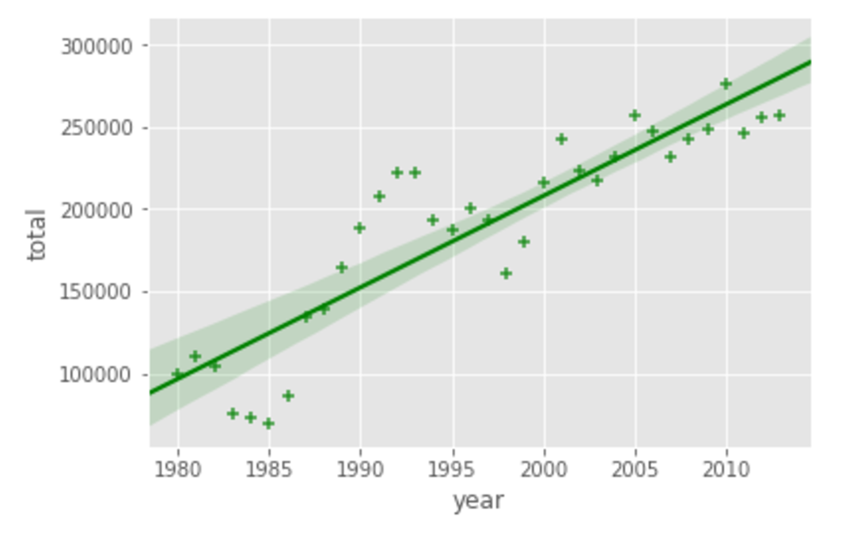





1

data_df.plot(kind="regplot", color="green", marker="+")





1

2

import seaborn as sns

ax = sns.regplot(x="year", y="total", data=data_df, color="green")





1

2

import seaborn as sns

ax = sns.regplot(x="total", y="year", data=data_df, color="green")





1

data_df.plot(kind="regression", color="green", marker="+")





1

2

import seaborn as sns

ax = sns.regplot(x="year", y="total", data=data_df, color="green", marker="+")

**Correct**

Correct.

**1 / 1 point**

3.Question 3

A regression plot is a great way to visualize data in relation to a whole, or to highlight progress against a given threshold.



True.



False.

**Correct**

Correct.

**1 / 1 point**

4.Question 4

The easiest way to create a waffle chart in Python is using the Python package, PyWaffle.



True.



False.

**Correct**

Correct.

**1 / 1 point**

5.Question 5

A word cloud (choose all that apply)



is a depiction of the meaningful words in some textual data, where the more a specific word appears in the text, bigger and bolder it appears in the word cloud.

**Correct**

Correct.



is a depiction of the frequency of different words in some textual data.

**Correct**

Correct.



can be easily created using Matplotlib using the scripting layer.

**This should not be selected**

Incorrect. A word cloud cannot be easily created using Matplotlib.



is a depiction of the frequency of the stopwords, such as a, the, and, in some textual data.



can be generated in Python using the *word_cloud* package that was developed by **Andreas Mueller**.

**Correct**

Correct.